Name: Mrs. Rupali N Hosmani.

Course: Executive Post Graduate Certification in Cloud Computing

Contact No. 7720003531

**Assignment 7: Simple Storage Service (S3)**

**Tasks To Be Performed:**

1. Create an S3 Bucket for file storage.

2. Upload 5 objects with different file extensions.

3. Enable versioning for the bucket created in task 1.

4. Re-upload any 2 files already uploaded to verify if versioning works.

5. Use the created bucket in the previous task to host static websites, upload an index.html file and error.html page.

6. Add a lifecycle rule for the bucket: a. Transition from Standard to Standard-IA in 60 days b. Expiration in 200 days.

**1.Create an S3 Bucket for file storage.**

**Steps:**

1. Go to S3 Console & create bucket.

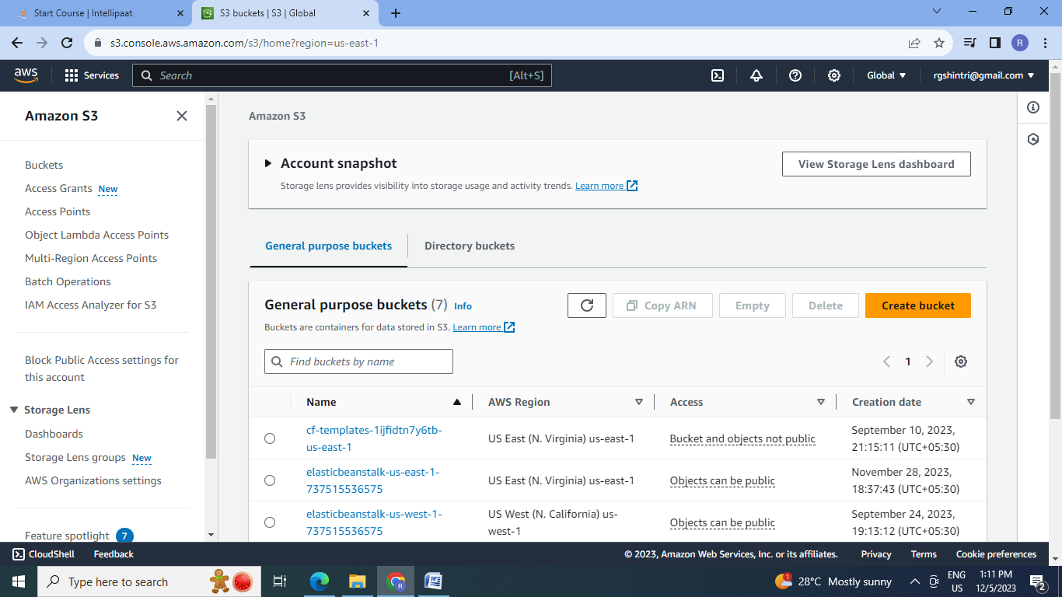

2.Give Unique Bucket name & create bucket:

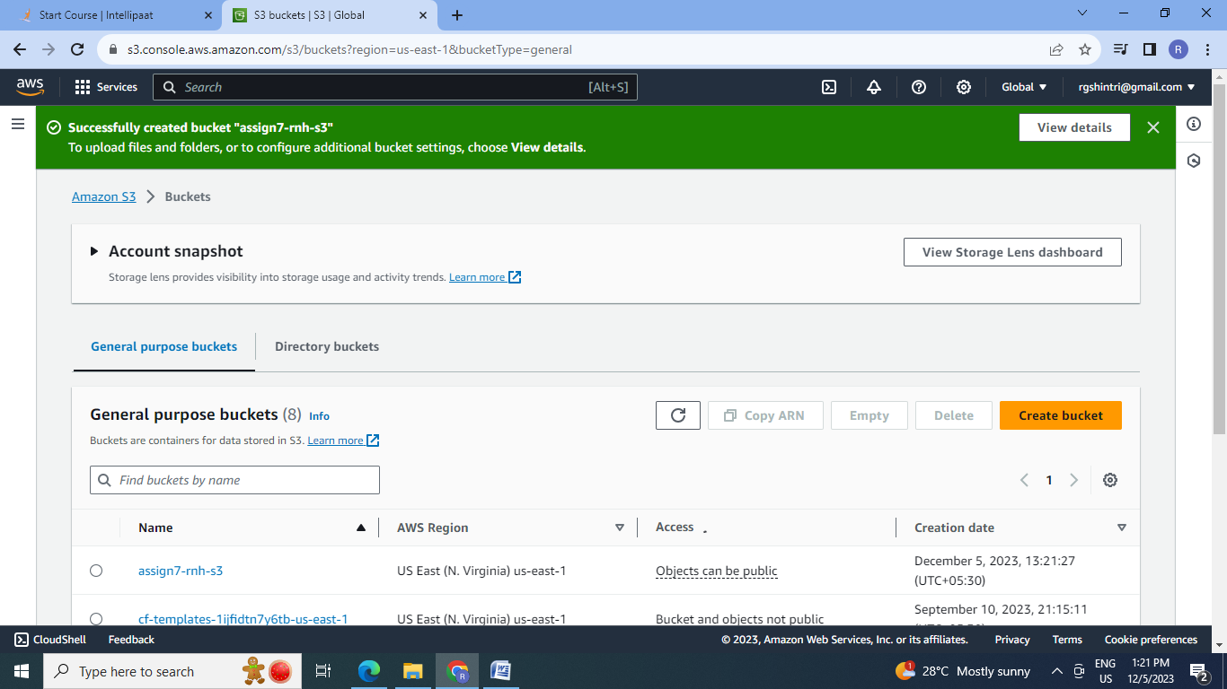

1. **Upload 5 objects with different file extensions:**

1.Upload the files with different extensions.

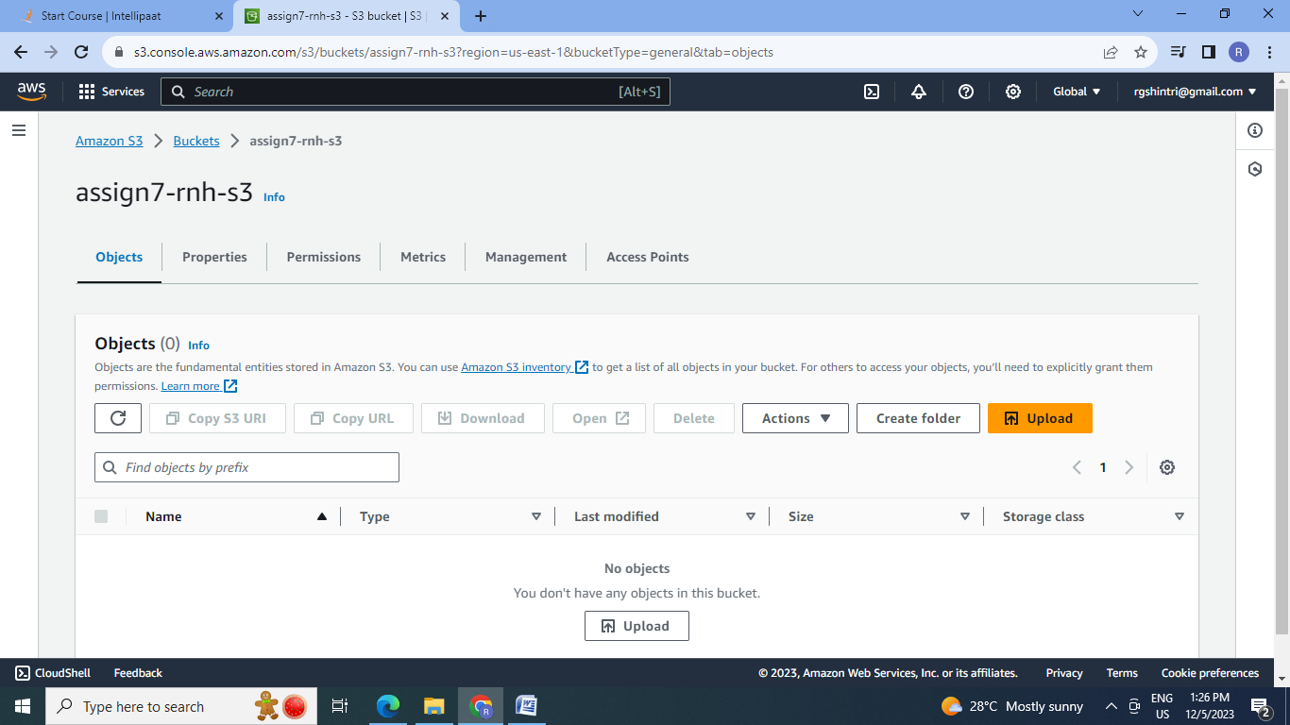

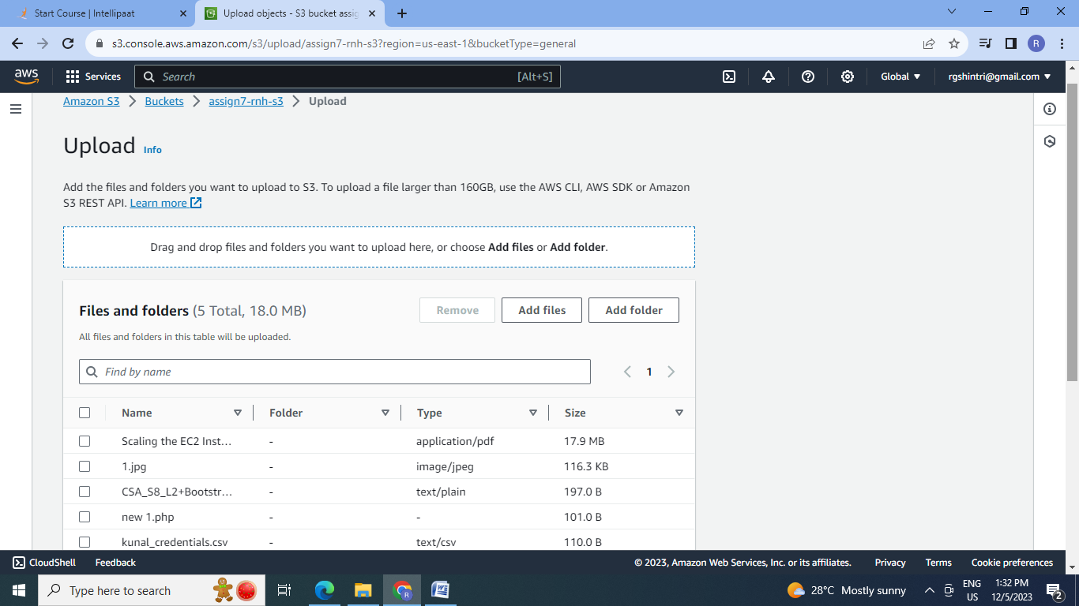

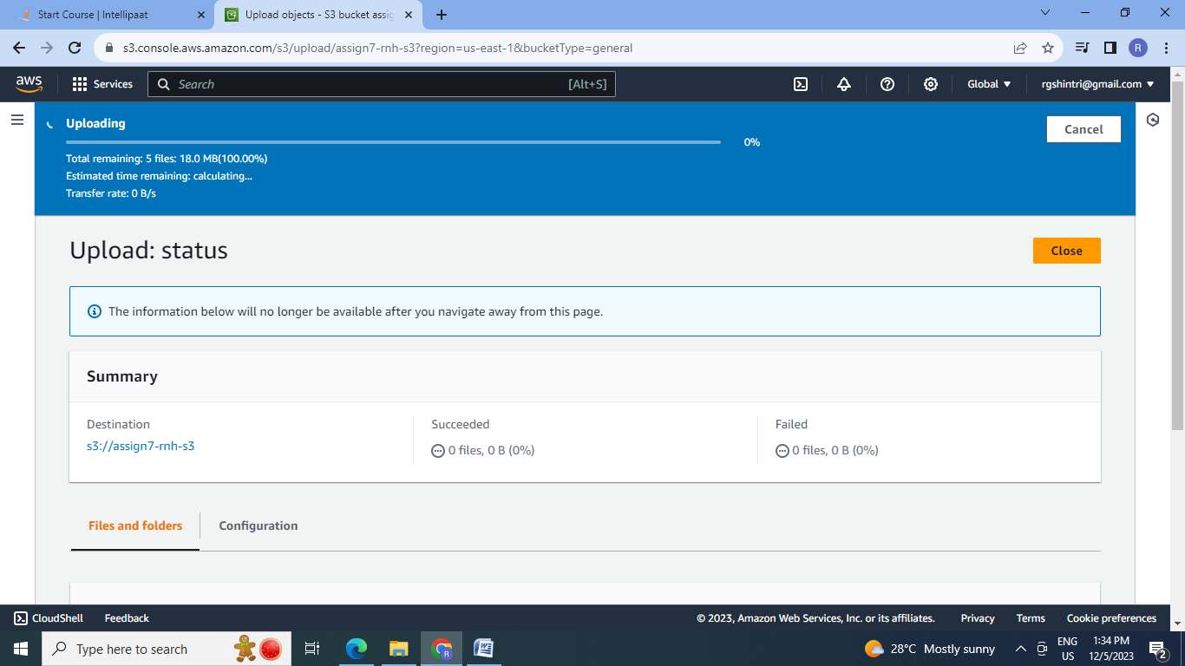

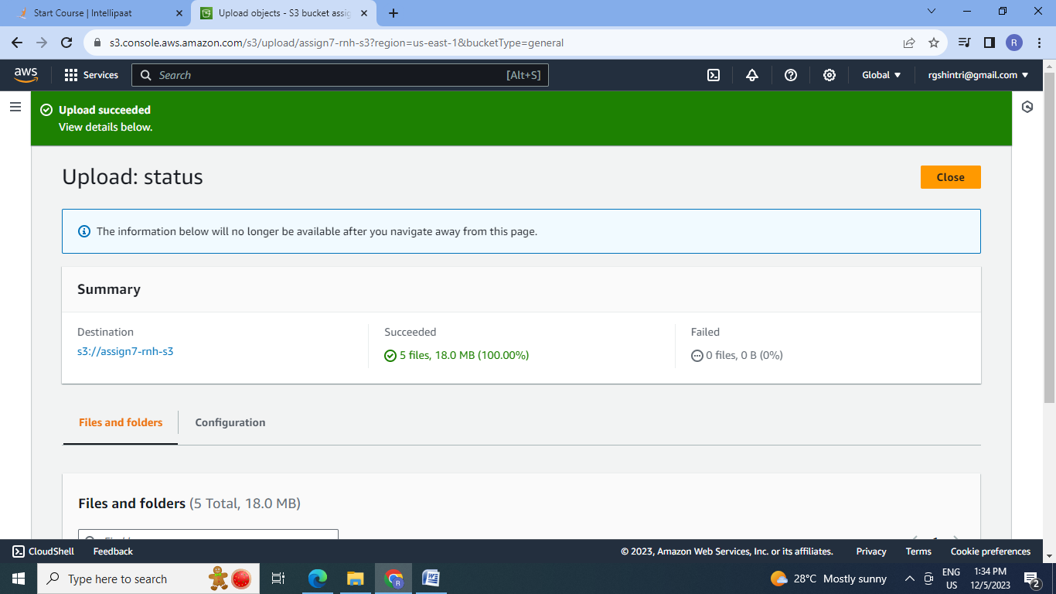

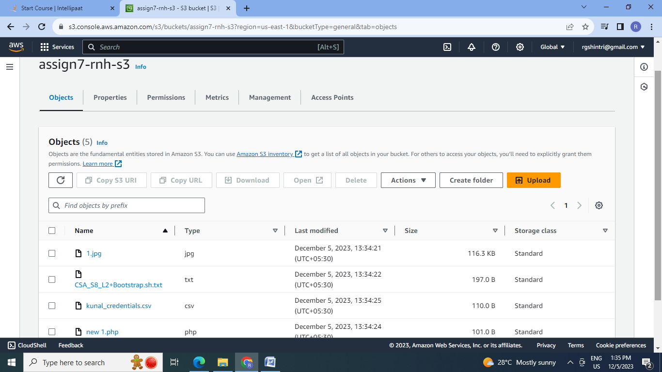

2.Select a particular object & check its properties & contents: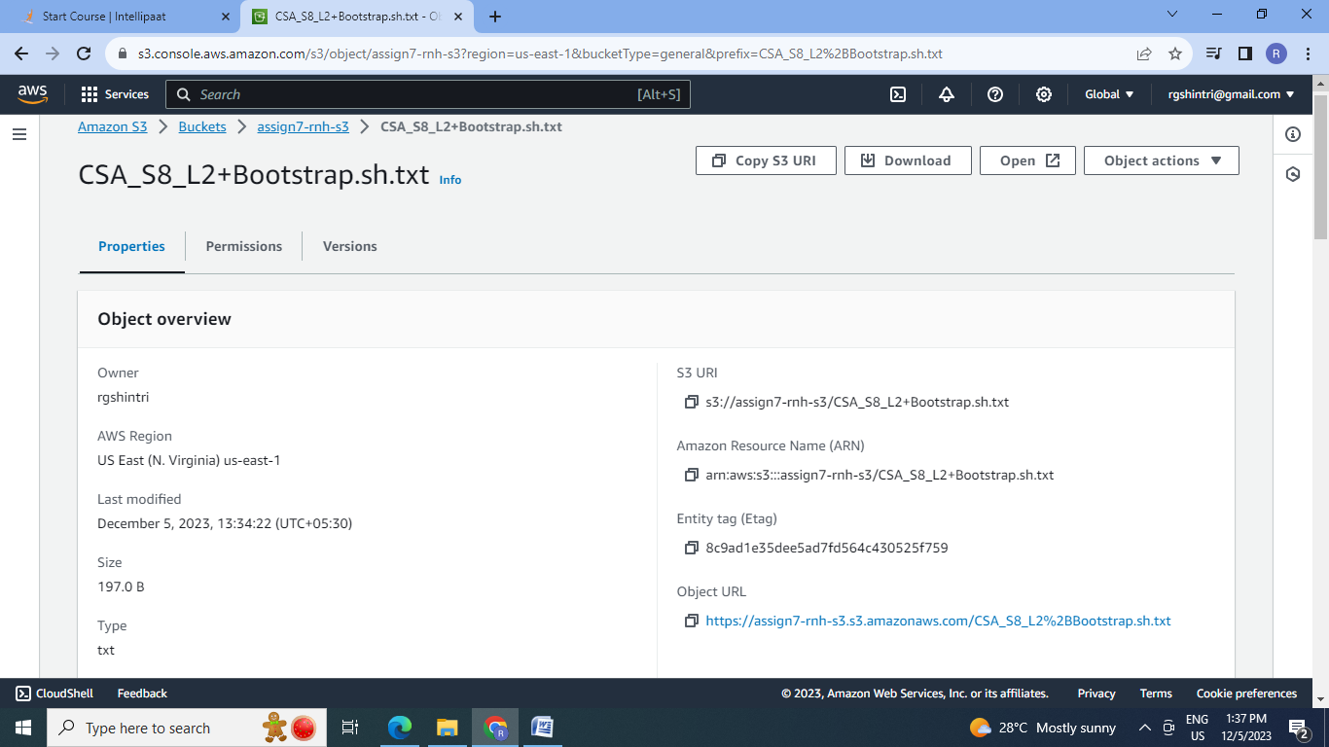

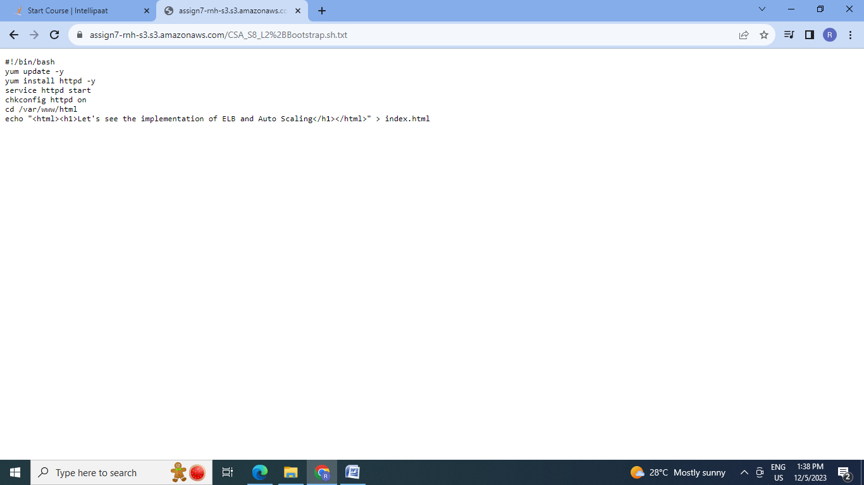

1. **Enable versioning for the bucket created in task 1.**

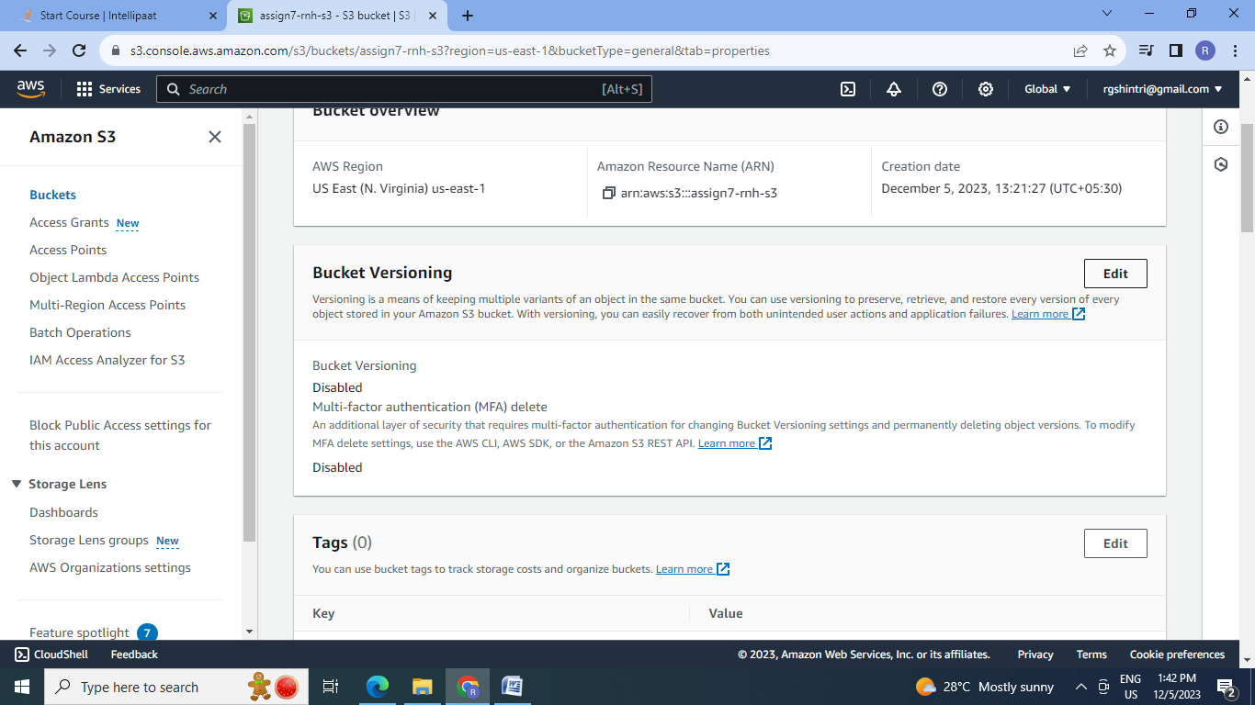

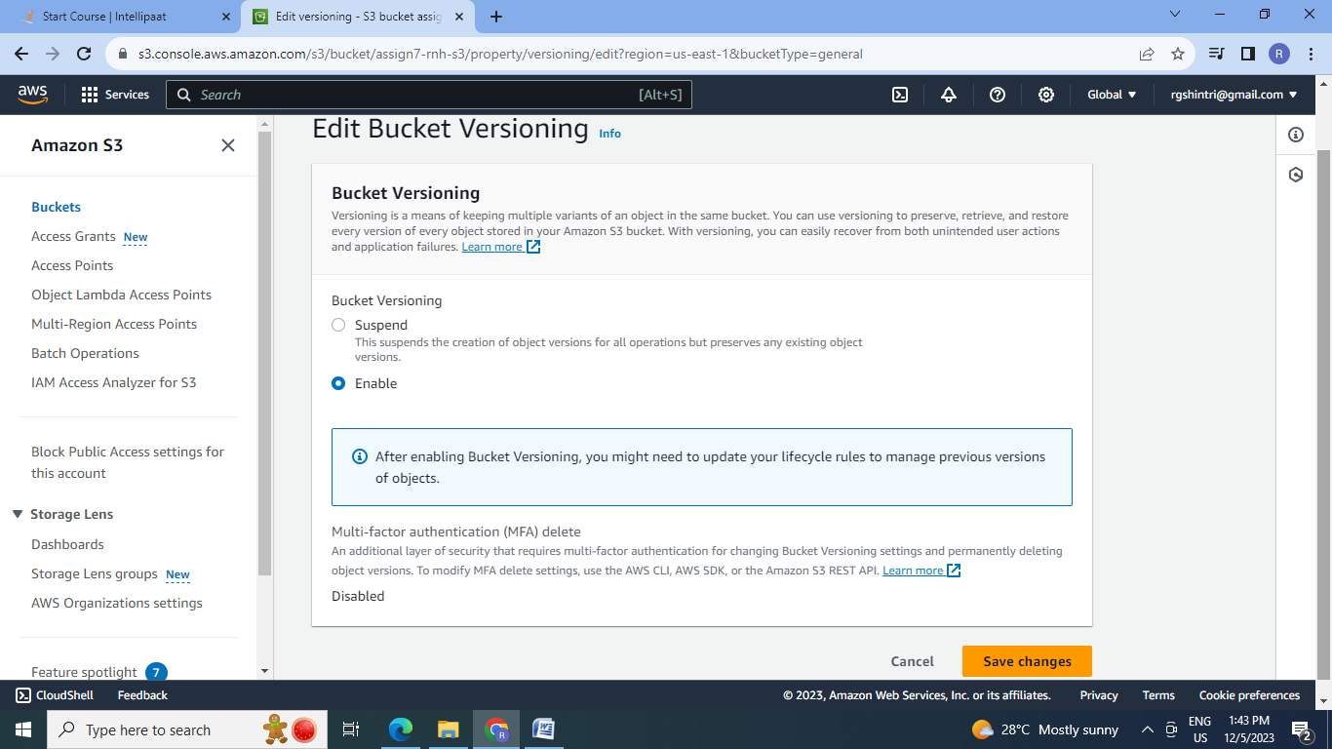

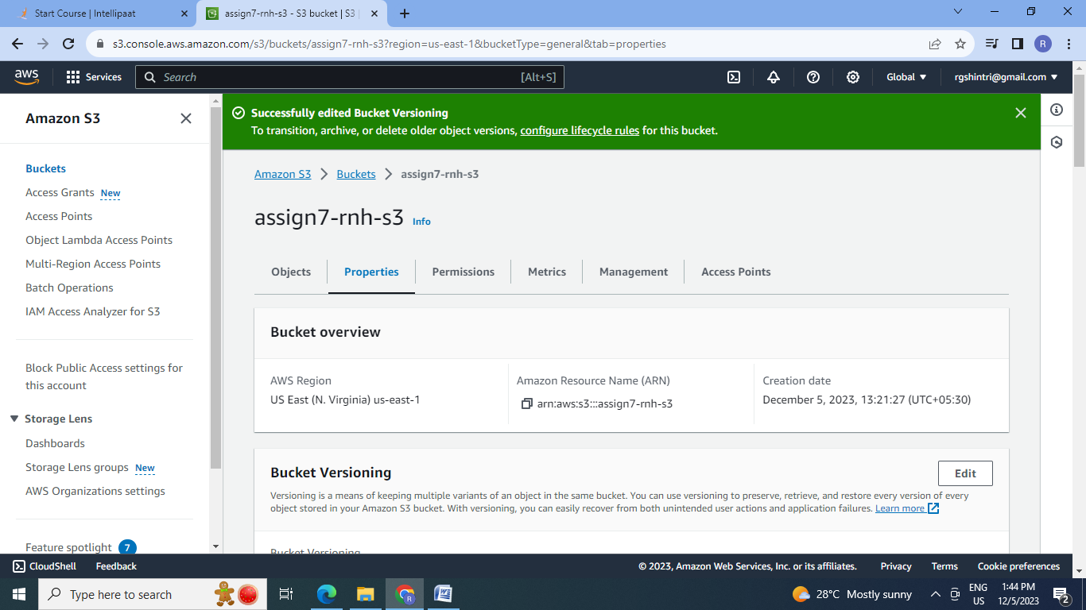

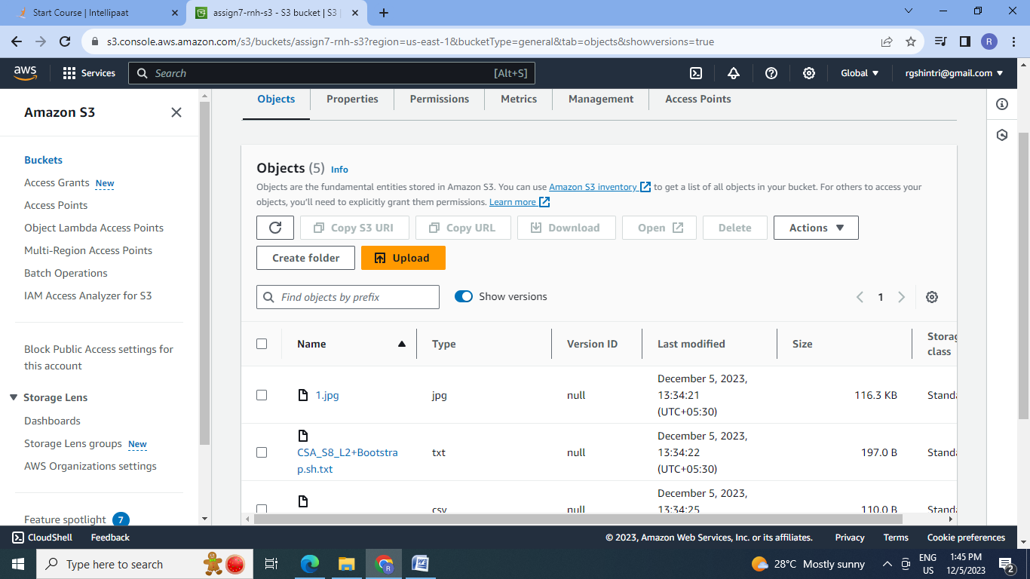

1. **Re-uploaded 1.jpg file & new 1.php file already uploaded to verify if versioning works.**

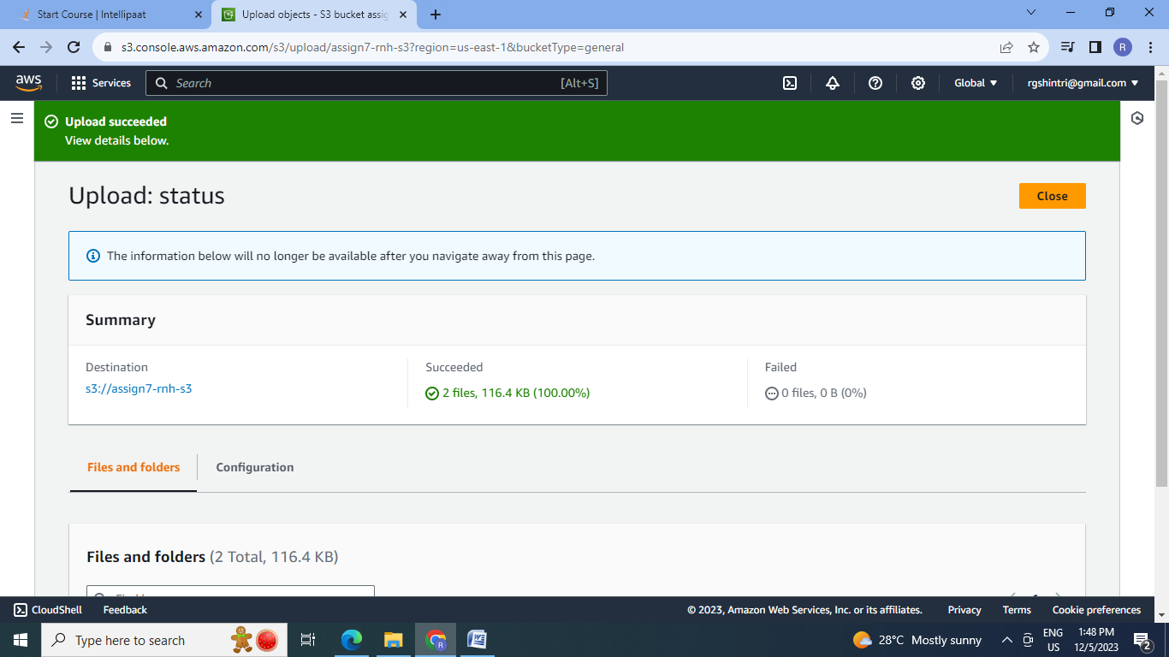

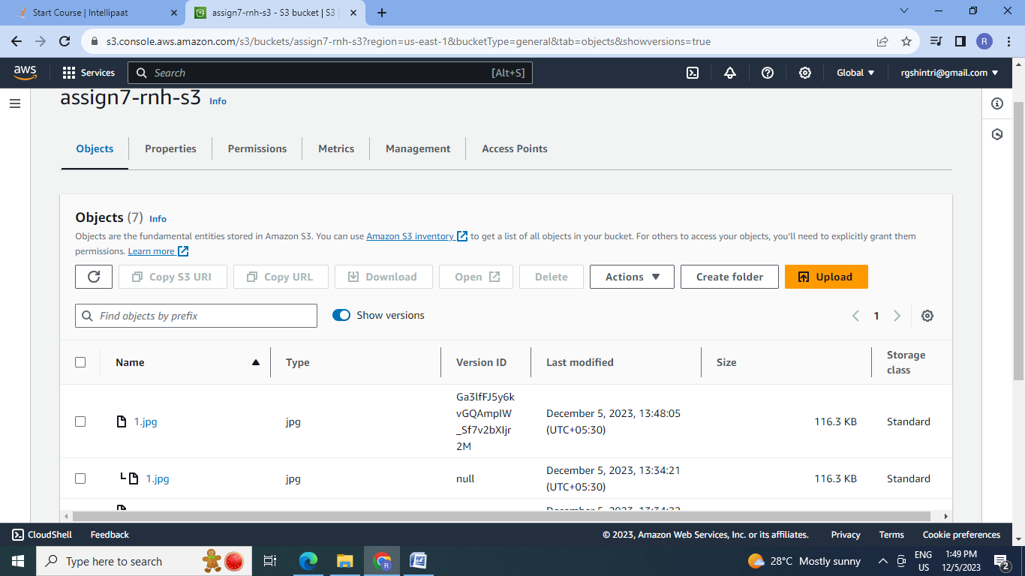

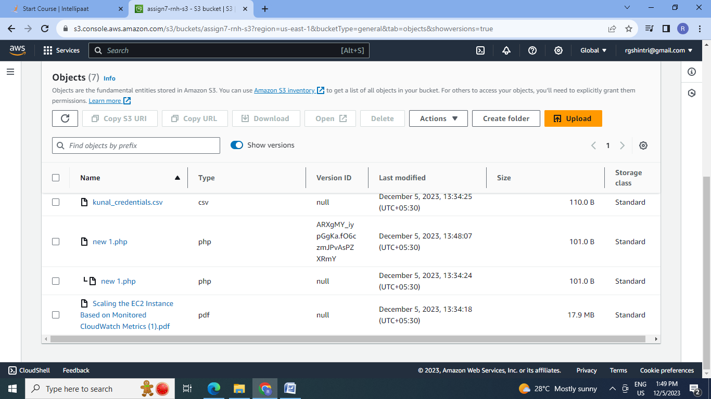

1. **Use the created bucket in the previous task to host static websites, upload an index.html file and error.html page.**

Steps:1. First create 2 html files as index.html & error.html and then upload the files in the s3 bucket.

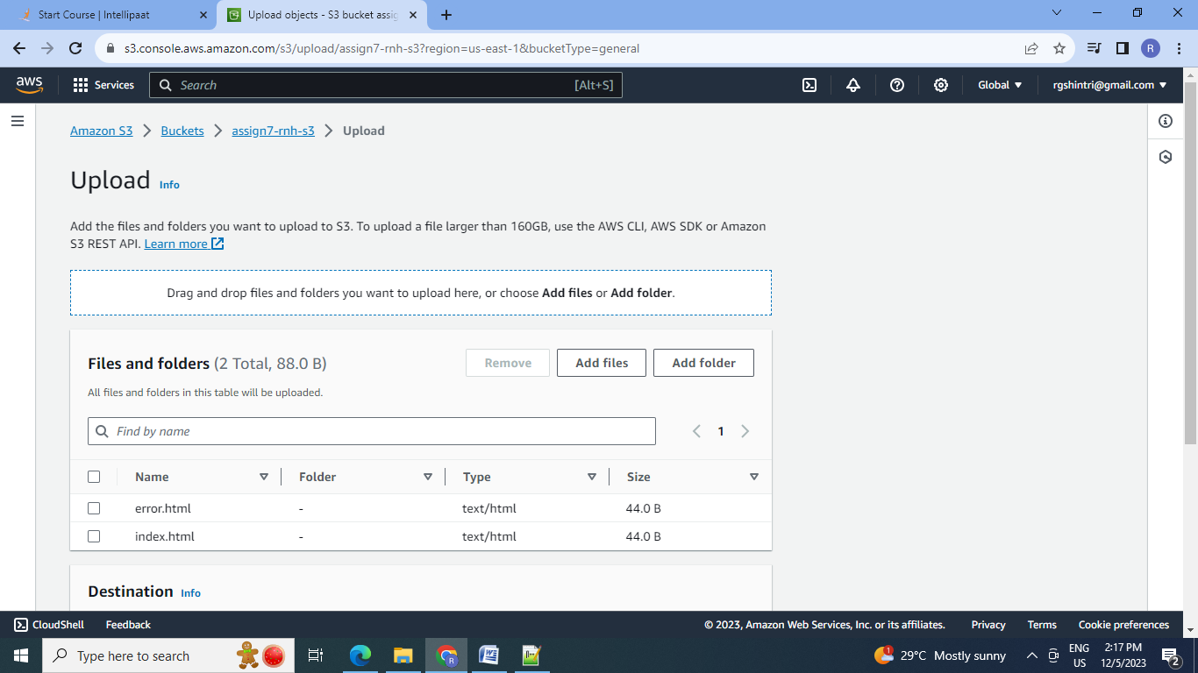

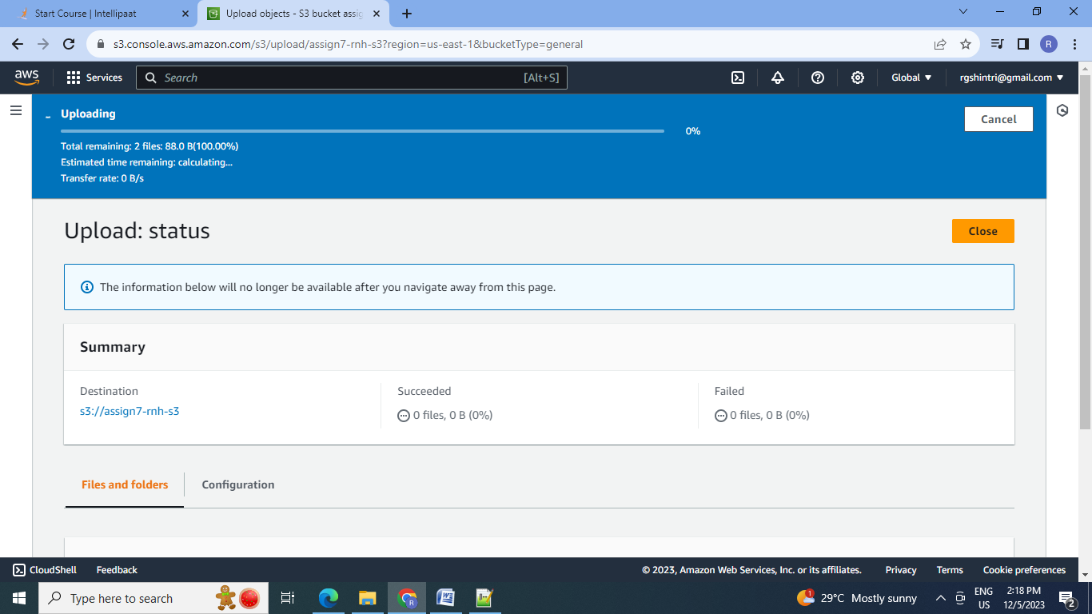

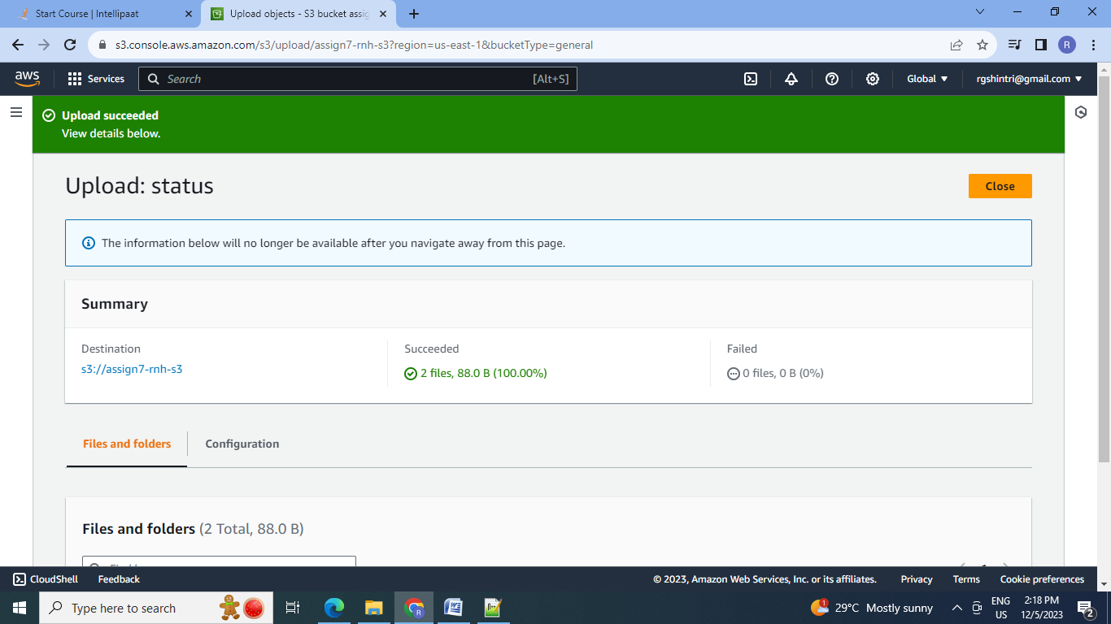

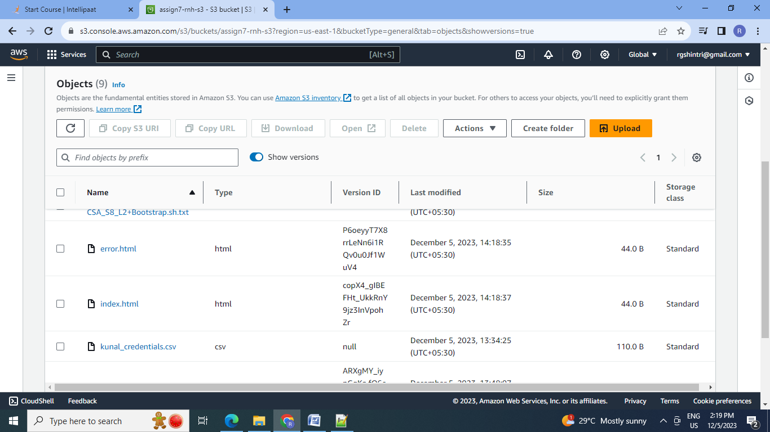

2.Go to properties & enable static web hosting:

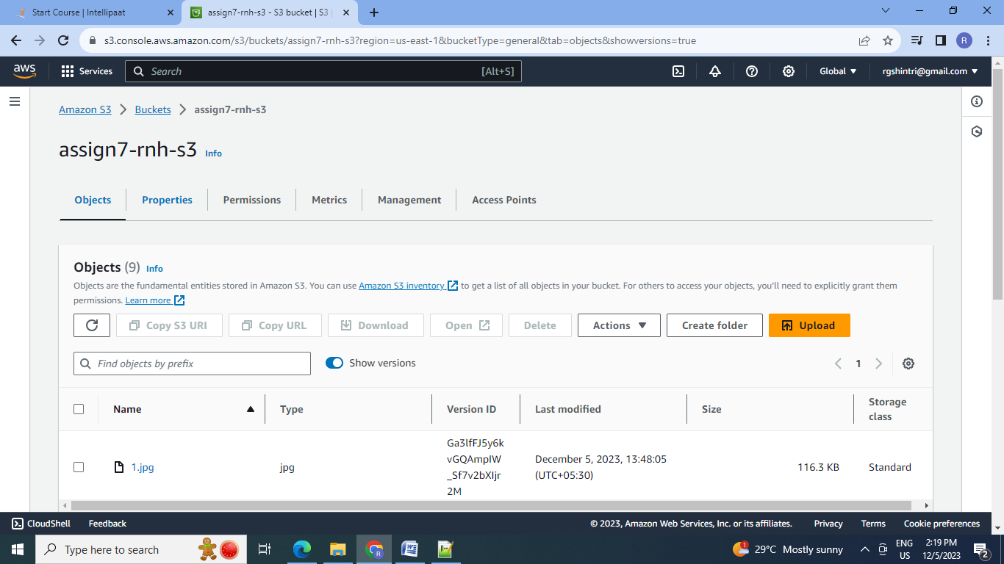

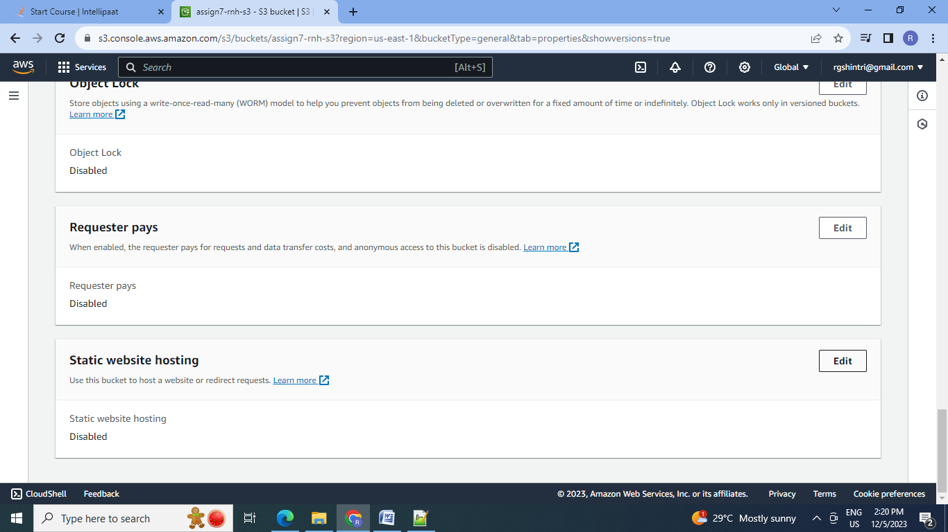

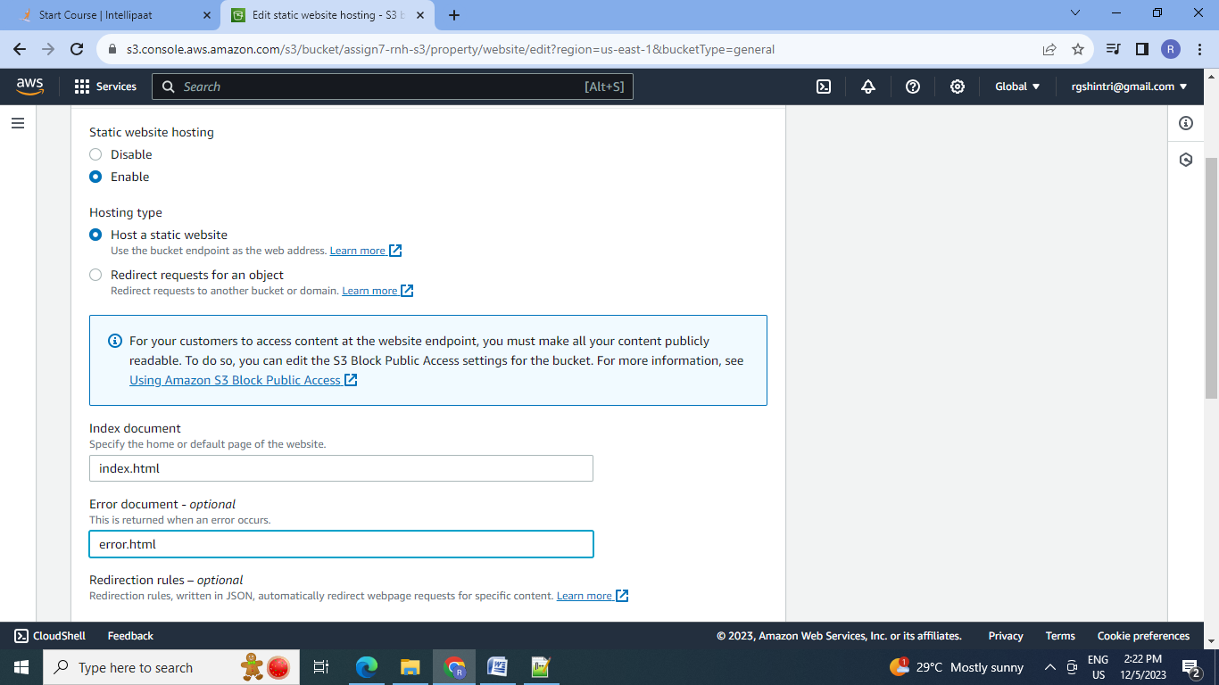

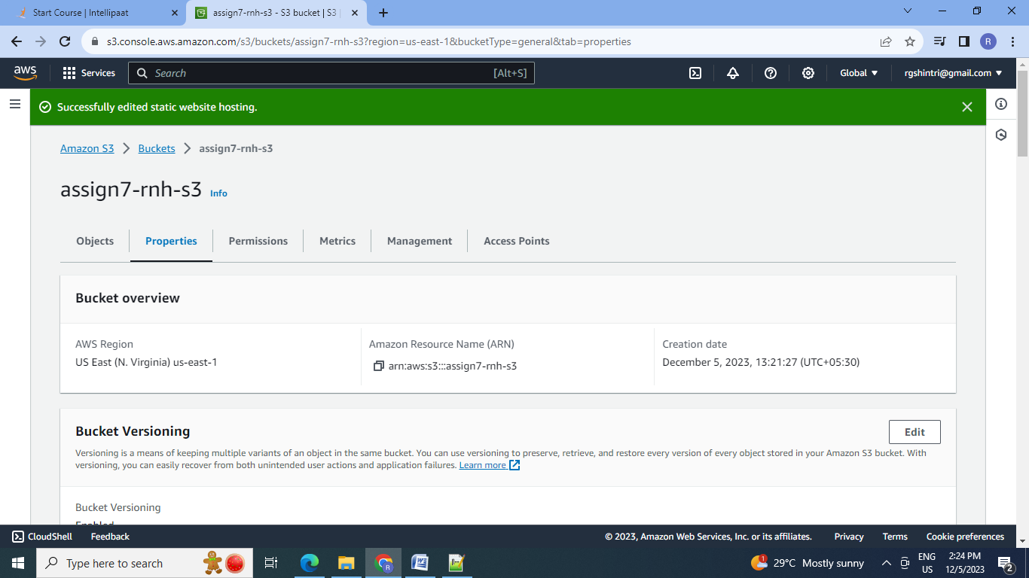

3.Make the two files i.e. index.html & error.html public:

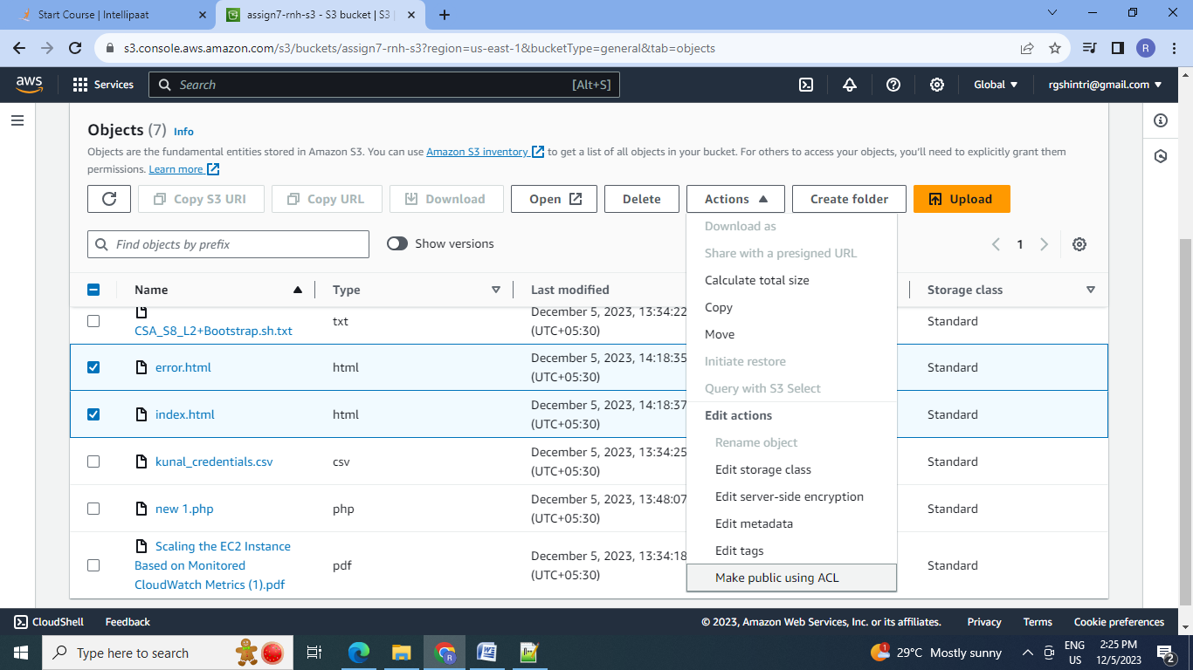

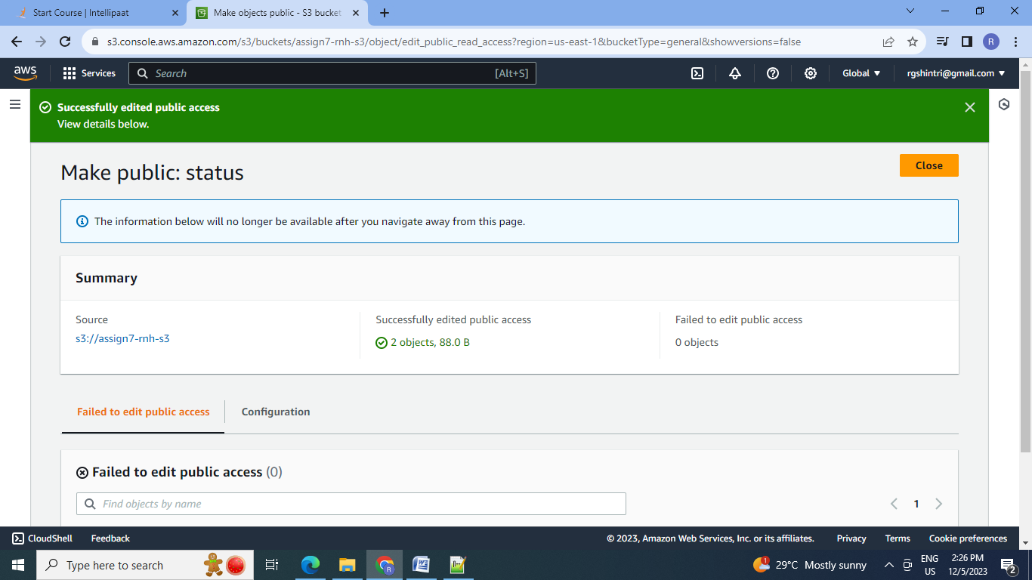

4.Click on the static web URL in properties:

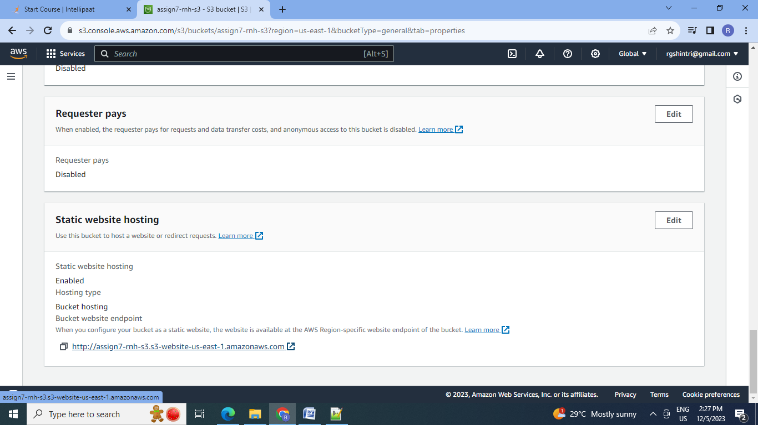

5.For correct URL it will give following O/P: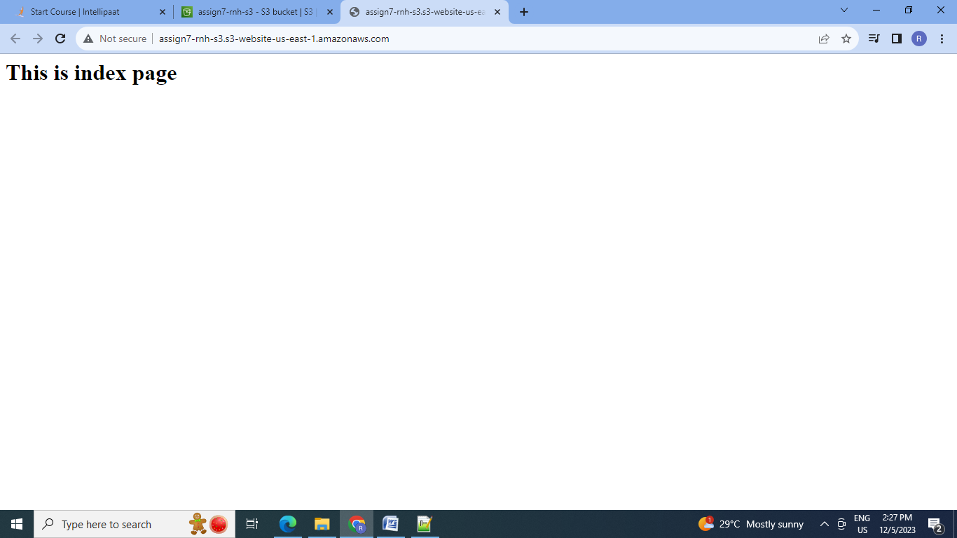

6.For incorrect URL it will give following O/P:

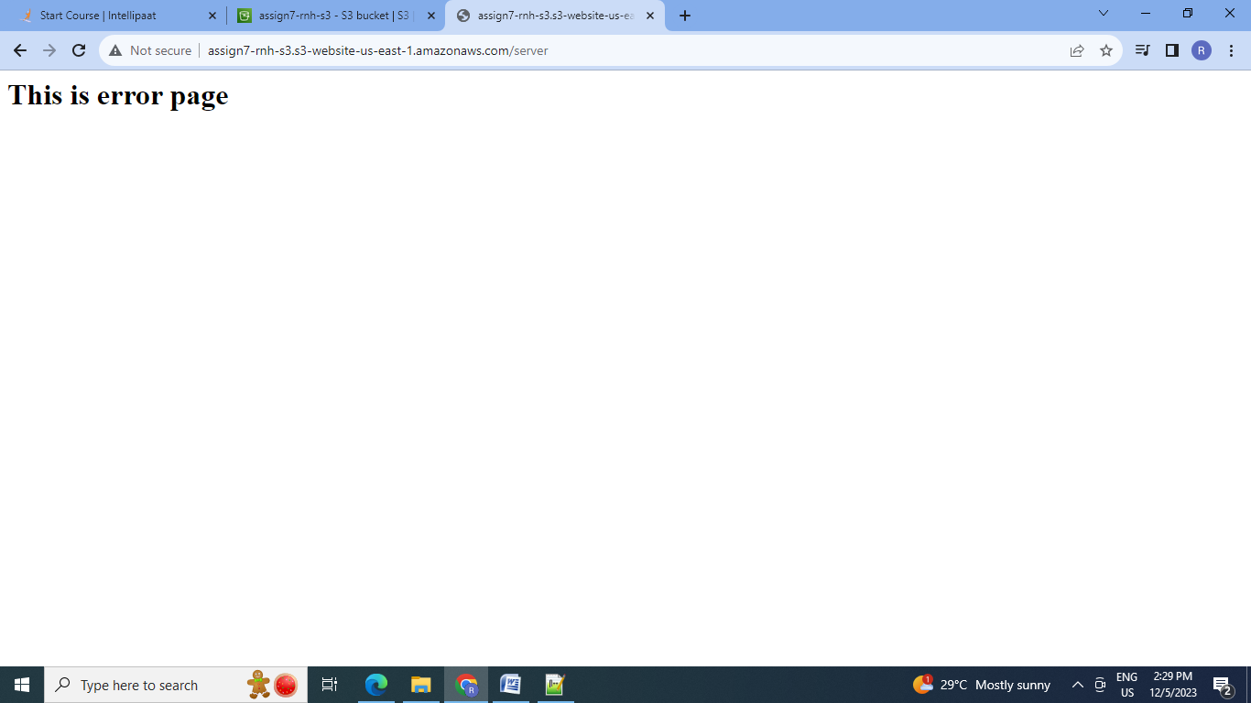

**6. Add a lifecycle rule for the bucket:** a. Transition from Standard to Standard-IA in 60 days b. Expiration in 200 days.

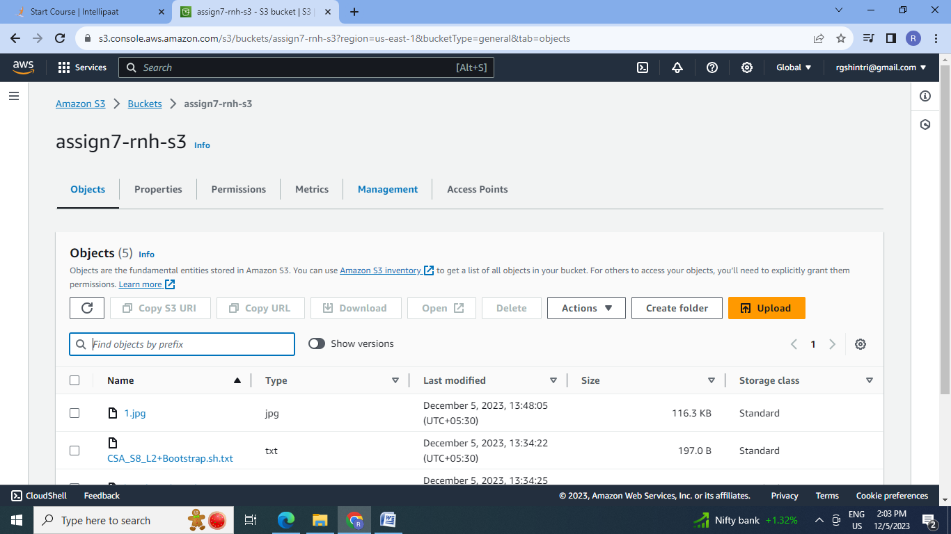

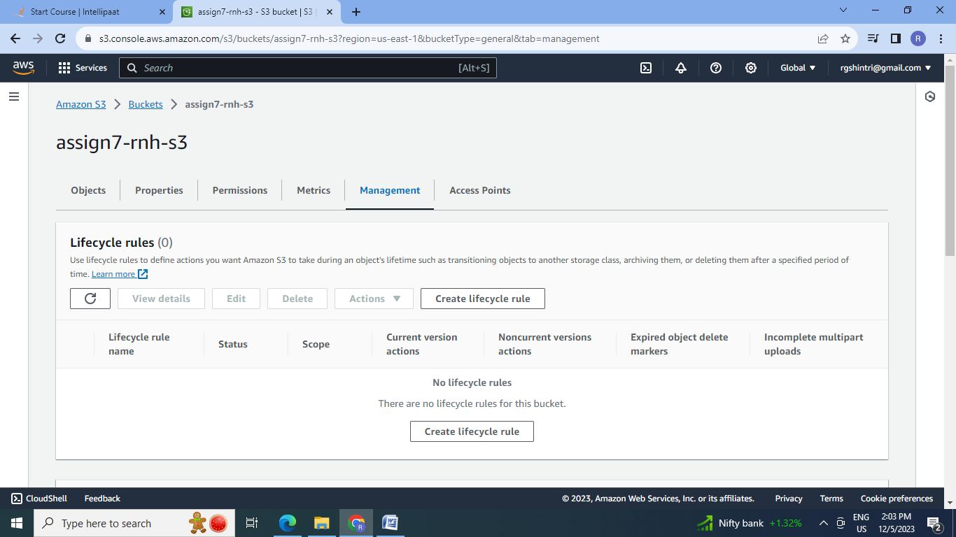

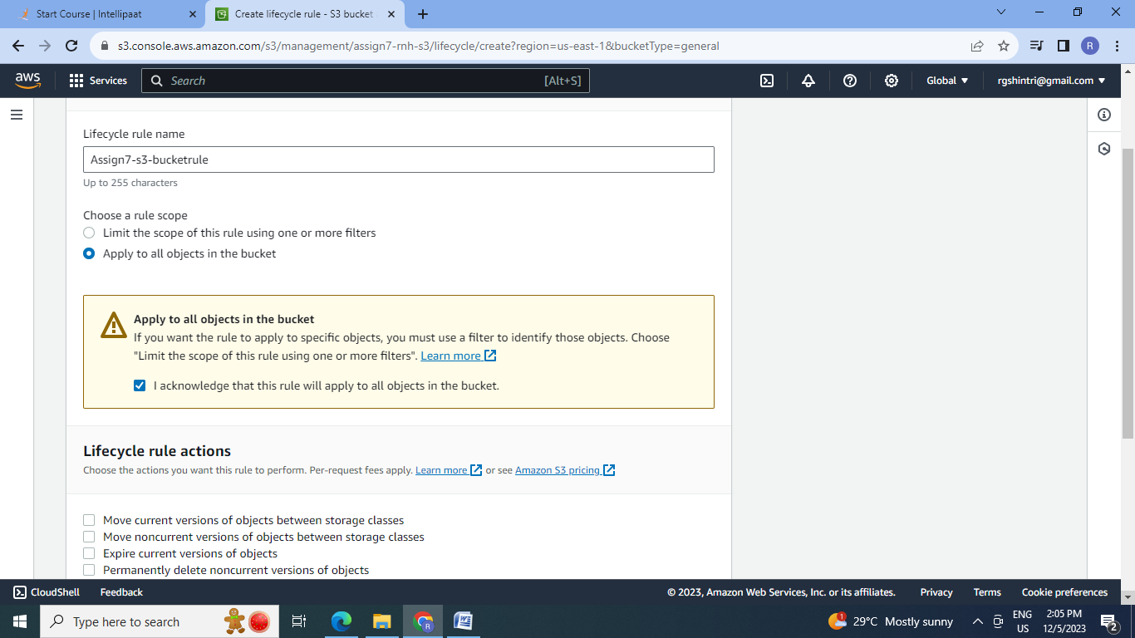

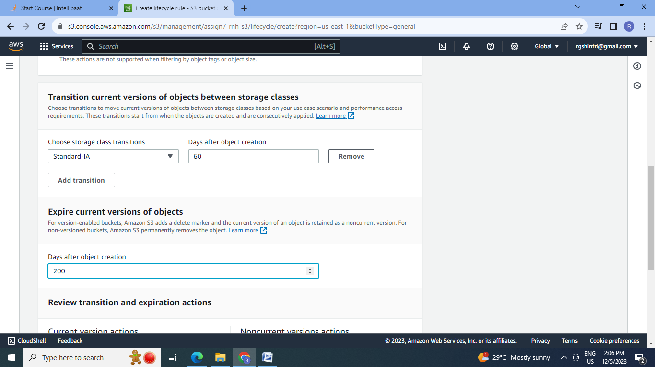

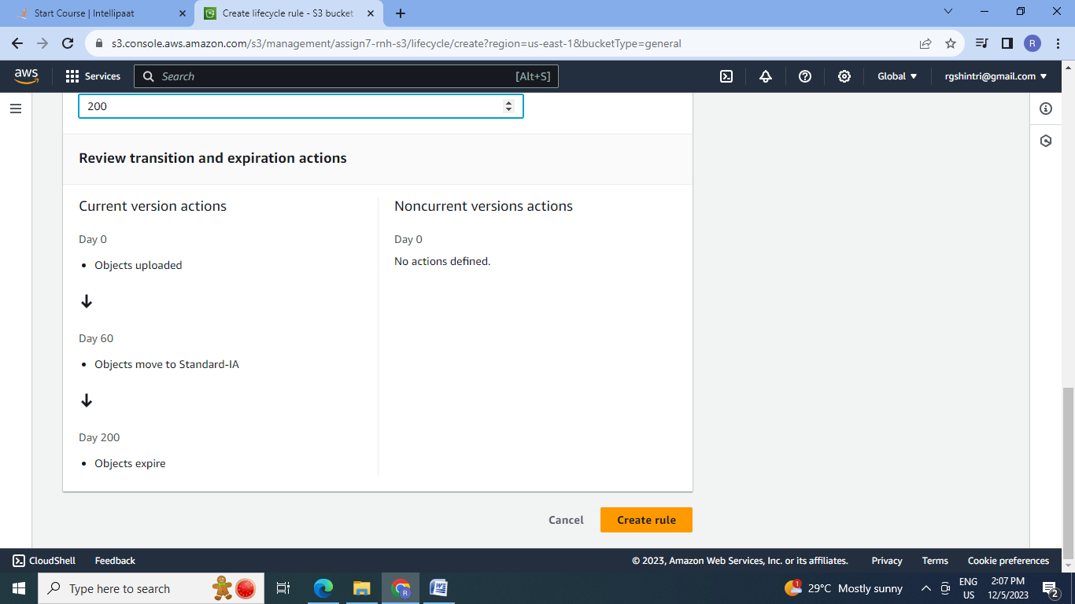

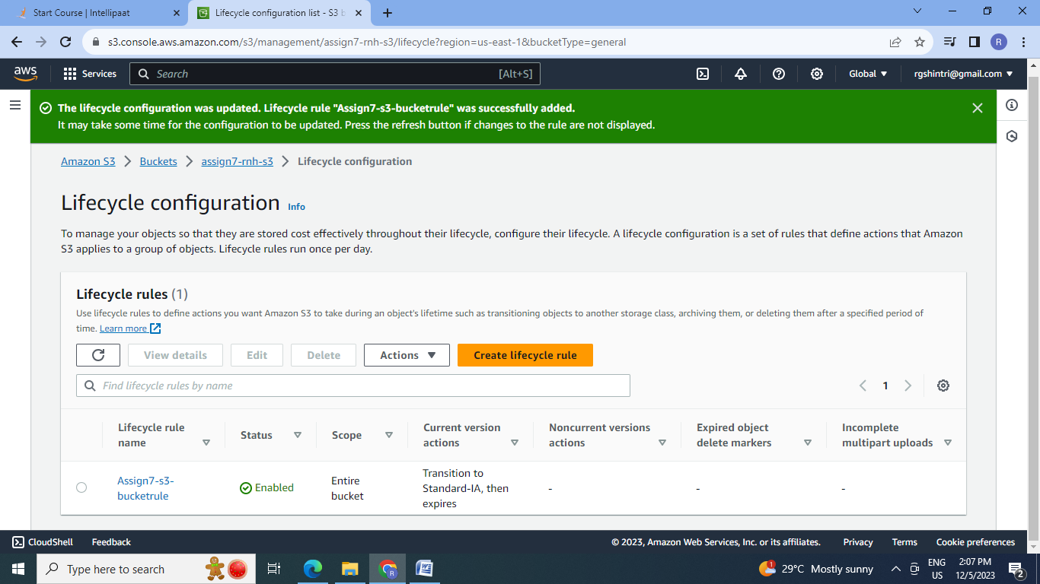

**Conclusion:** 1.Using Simple storage service (S3) we can upload & maintain the different versions of the objects globally. 2. According to the need of the object we can set the storage class & we can do the transitions also by applying life cycle rules. 3. Using S3 we can host the static website using the objects stored in it.

